ECMAScript 6 introduces the concept of class available in traditional object-oriented languages. In ECMAScript 6, the class syntax is syntactical sugar on top of the existing prototype-based inheritance model. It does not add a new object-oriented inheritance model to JavaScript.

In this unit, you create an alternative implementation of the mortgage calculator application using a Mortgage class.

## Part 1: Using a Class

1. Since this is an alternative implementation rather than the logical continuation of the previous implementation, make a copy of index.html and main.js in case you want to go back to that version.
2. In main.js, remove the import statement at the top of the file.
3. Add the following class definition at the top of file:

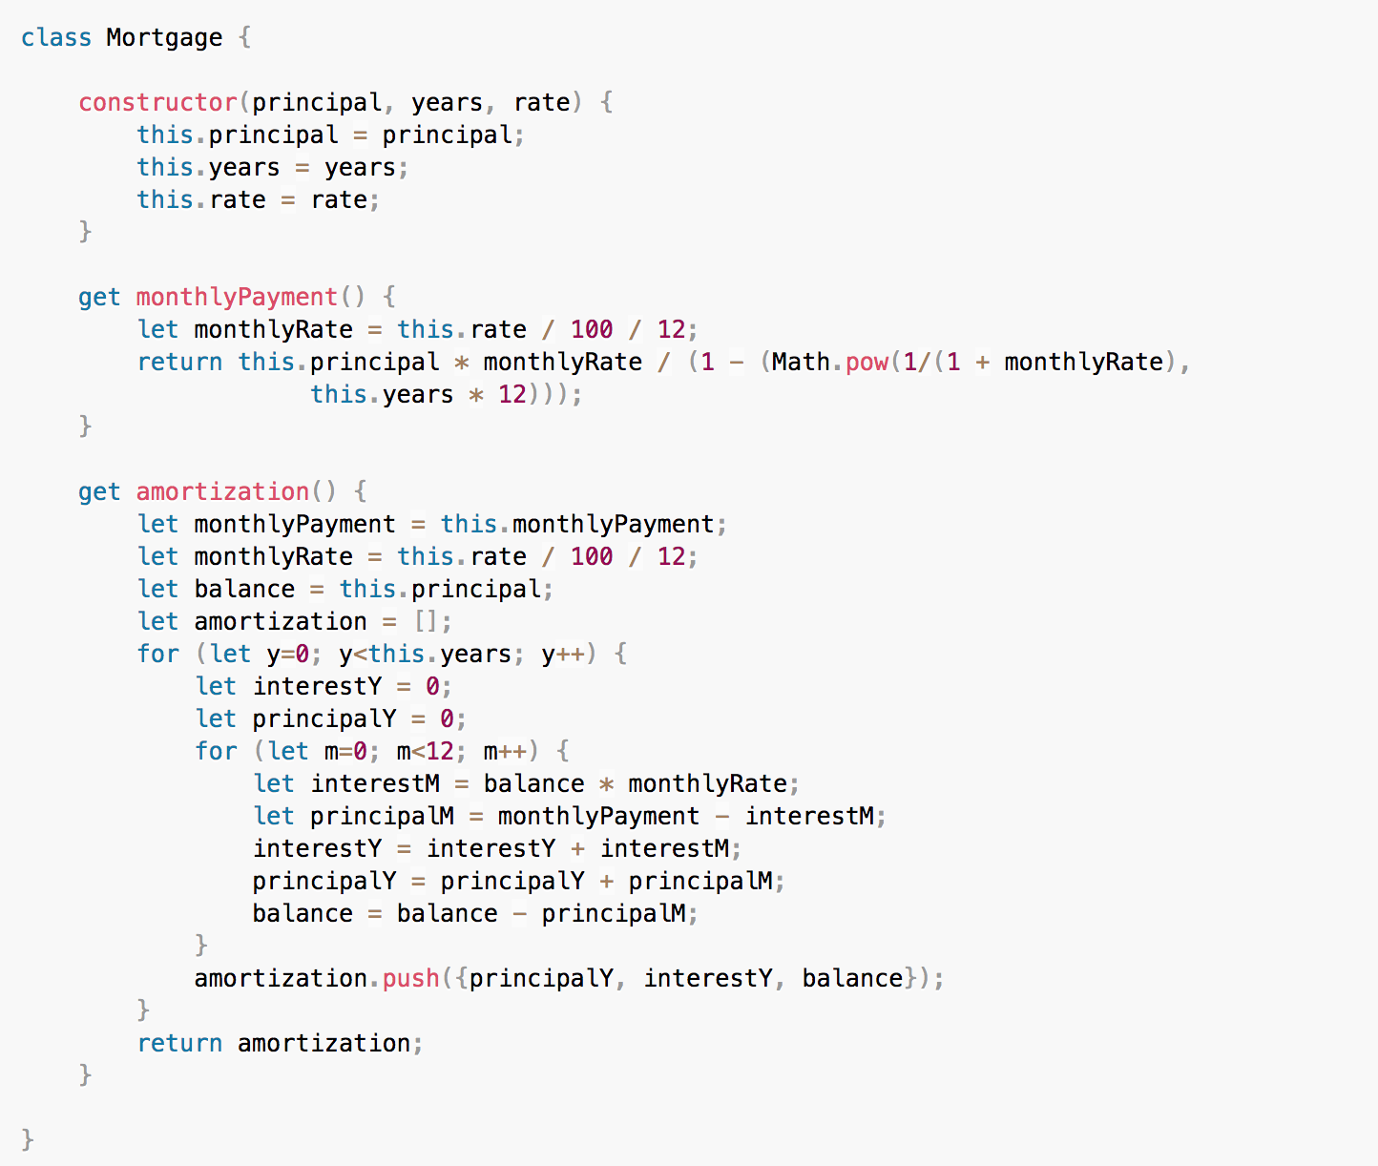

1. Modify the **calcBtn** click event handler as follows:

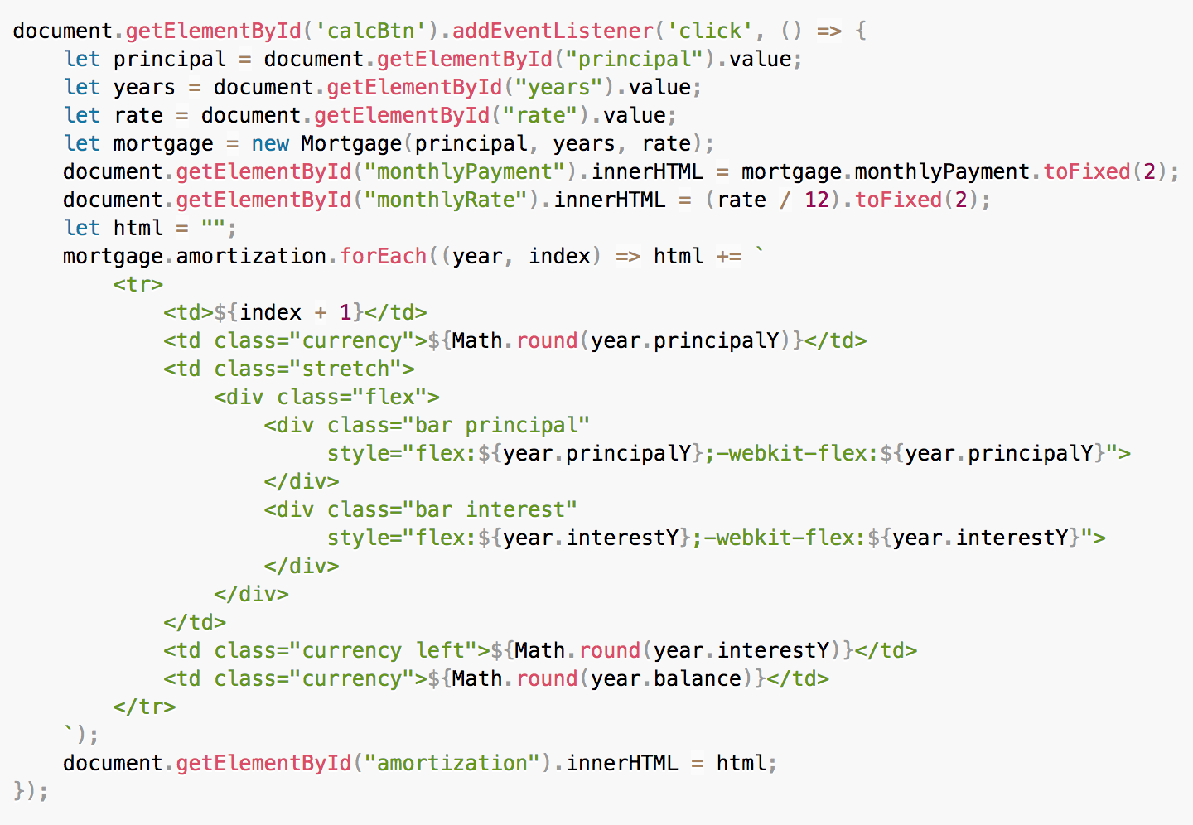

1. On the command line, type the following command to rebuild the application:

npm run webpack

1. Open a browser, access [http://localhost:8080](http://localhost:8080/), and click the **Calculate** button.

## Part 2: Using Classes in Modules

To create the module:

1. Create a new file named mortgage2.js in the js directory.
2. Copy the Mortgage class definition from main.js into mortgage2.js.
3. Add the export default keywords in front of the class definition. mortgage2.js should now look like this:

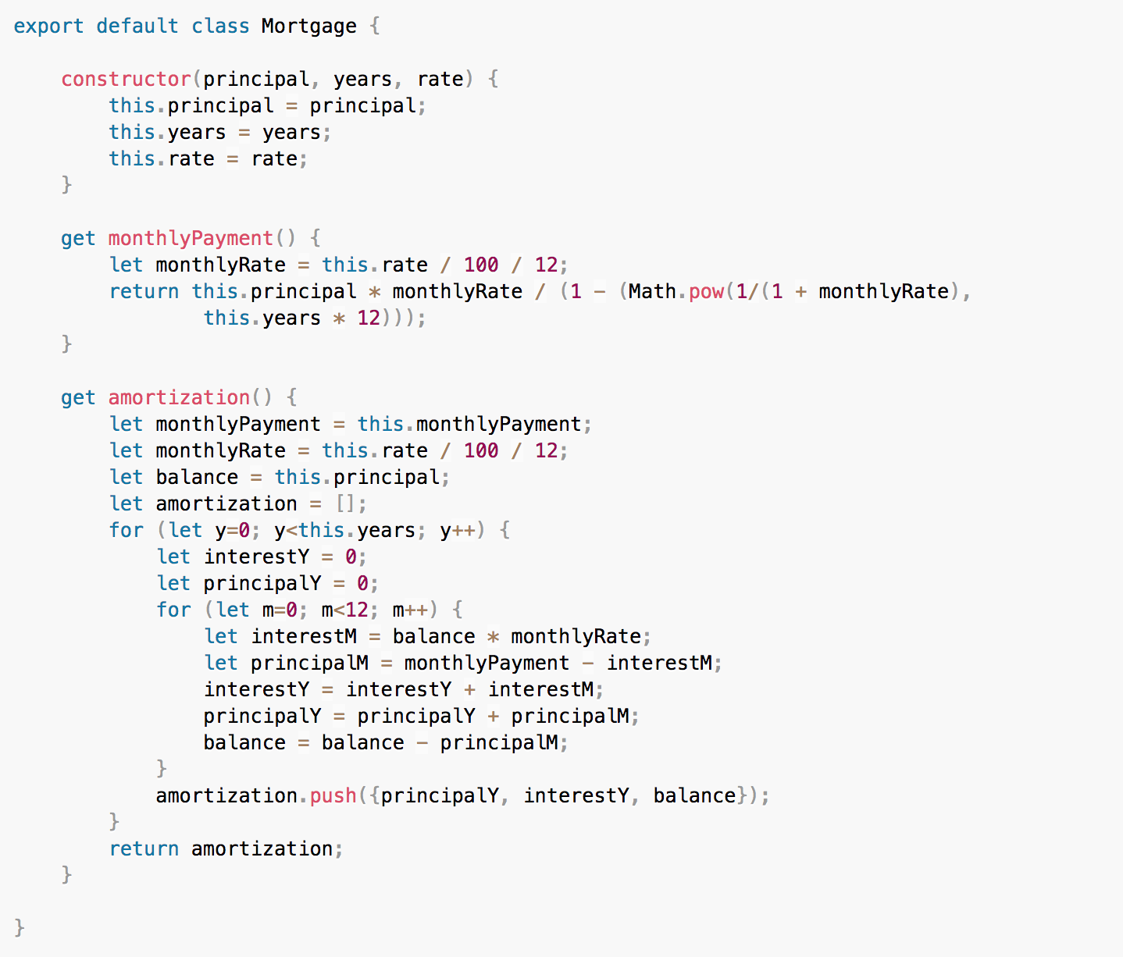

To use the module:

1. In main.js, remove the Mortgage class definition.
2. Import the mortgage module. Add the following import statement as the first line in main.js:

import Mortgage from './mortgage2';

To build the project:

1. On the command line, type the following command to rebuild the application:

npm run webpack

1. Open a browser, access [http://localhost:8080](http://localhost:8080/), and click the **Calculate** button.